
TRED AVON YACHT CLUB
SAILING INSTRUCTIONS
PENGUIN INTERNATIONALS AUGUST 27THAND 28TH 2010
(revised 8/24/10 j.s.c.)

1.Registration:
On line at www.TAYC.com required
Or Friday in the Club 9:00 -1030
$50.00 Seniors and $30.00 Juniors
Box Lunches $8
Skippers’ Meeting: Fri. 8/27 11:00

2. Eligibility:
As listed in the Notice of Race

3. RULES:
The regatta will be governed by the Racing Rules of Sailing, Class rules, the Notice of Regatta, and these sailing instructions.

4. MANAGEMENT OF RACES:
Races will be sailed under the management of the Tred Avon Yacht Club Race Committee.

5. NOTICES TO COMPETITORS:
Notices will be posted on the Official Regatta Notice Board located in the Club house adjacent to lobby.

6. SCHEDULE OF RACES:
6.1 One or more completed races will constitute the regatta. The Committee will start as many races as time and conditions allow.
6.2 Races are scheduled as follows:
Day Warning
8/27 1200
8/28 9:30

6.3 Any change in the schedule will be posted on the Official Regatta Notice Board or will be made by hailing all contestants after the completion of a race.
6.4 Contestants should be ready to leave for the starting area at least 45 minutes before the announced warning time.

7. RACING AREA:
The racing area will be South of TAYC on Tred Avon River,

8. THE COURSE:
Refer to Course Diagrams below
8.1 The course designation will be displayed on the committee (Signal) boat.
8.2 Course can be shortened at any mark of course.

9. MARKS:
9.1 Rounding Marks will be:
Large Red Balls (Bemis)
9.2 The starting and finishing mark is a drop mark on the port side of the Signal Boat
9.3 A mark attached to the leeward side of the committee boat is considered part of the boat.

10. THE START:
10.1 Race will be started using Appendix S– Three Minute Sound-Signal Starting System.
10.2 The Race Committee may elect to sound a “Heads Up” signal approximately 30 seconds before the Warning sound.
10.3 The starting line will be between an orange flag on the Signal Boat and a drop mark.
10.5 A yacht shall start no later than four minutes after her starting signal.

11. RECALLS:
11.1 Individual recalls will be signaled in accordance with racing rule 29.1
11.2 The Race Committee will attempt to hail OCS starters however, whether or not the hail is heard, responsibility for starting properly rests with each yacht.
11.3 After a general recall has been signaled, a new warning signal for the recalled class will be made one minute after the lowering of Code Flag "First Substitute" with one sound.

12. ABANDONMENT AND CANCELLATION:
Abandonment and Cancellation will be governed by racing rule 32.

13. CHANGING COURSE AFTER THE START:
13.1 When changing the course after the start, the Race Committee will lay a new mark and remove the original mark as soon as practical.
13.2 A change of course will be signaled near a mark by a Race committee boat which will display Code Flag "C", make multiple sounds, and indicate the approximate compass bearing to the new mark. The change will be signaled before the first yacht has begun the leg toward the new mark although the new mark may not be in position at that time.

14. THE FINISH:
Refer to Course Diagrams below
The finishing line will be between an orange flag on a Race Committee boat and a drop mark.

15. TIME LIMIT:
If the first yacht fails to complete the course within 2 hours the race shall be abandoned. Any yacht not finishing within 30 minutes of the first boat in its class will be scored as DNF.

16. SAFETY:
16.1 Each contestant is solely responsible for his/her own safety.
16.2 The Race Committee may, in conditions it deems hazardous, require a contestant to accept assistance.
16.3 A Yacht that retires shall make every effort to notify a committee boat before leaving the area of the race course. If not possible, she shall notify the Race Committee immediately after arriving ashore.
16.4 Any boat that capsizes during a race as defined by the mast hitting the water, shall retire from that race.

17. PROTEST:
A Yacht desiring to protest must notify the other contestant involved. The protesting yacht shall notify the race committee boat at the finish line at the end of the race in which the foul was committed and receive acknowledgment. A written protest must be filed at the Clubhouse within one hour after the committee boat returns to the dock. Time and location of protest meetings will be posted on the official bulletin board in the club house.

18. SCORING:
18.1 Scoring shall be in accordance with the Low Point System, of Appendix A of RRS.
18.2 If 6 or more races are completed, a boat’s worst score shall be excluded.

COURSES

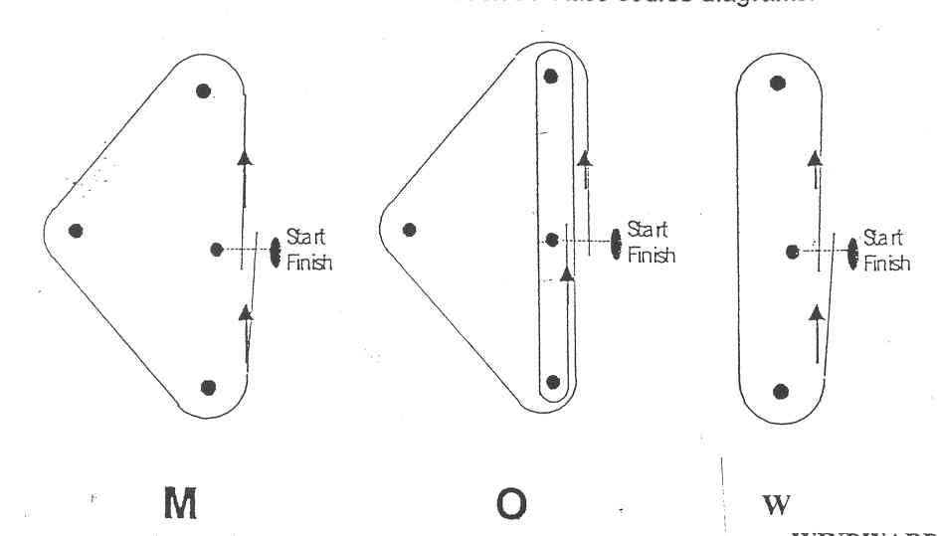

Note: Courses “M” or “W” may be once or twice around.
If twice around the course Board on the Signal Boat will indicate:
“M” x 2 or “W” x 2

